MACH4METAL

metalworking machinery
Transito 21
6909 DA BABBERICH Netherlands
Tel. +31 (0)316-247123
Fax: +31 (0)316-247956
info@mach4metal.com
www.mach4metal.com

Bank No : 66.52.13.883
IBAN : NL33 INGB 0665 2138 83
BIC : INGBNL2A
www.mach4metal.com

SAF Air Liquide plasma cutter

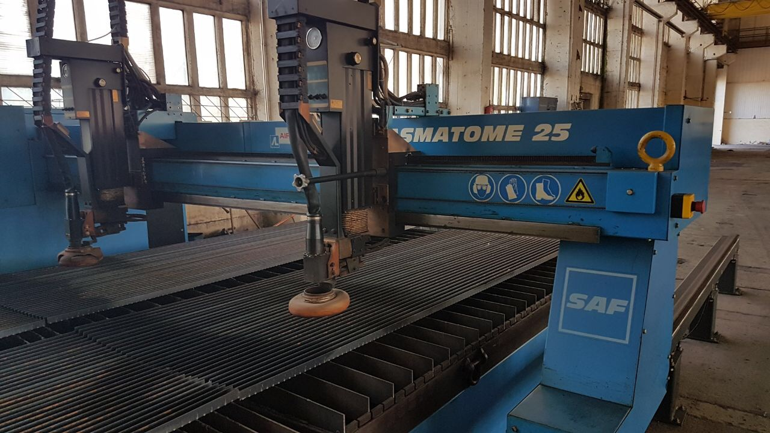
- Make : SAF Air Liquide
- Typ : PLASMATOME 25
- Age : 1998
- Mach. No. :

- Working area
- X Travel : 6.000
- Y Travel : 3.200
- Z Travel : 439
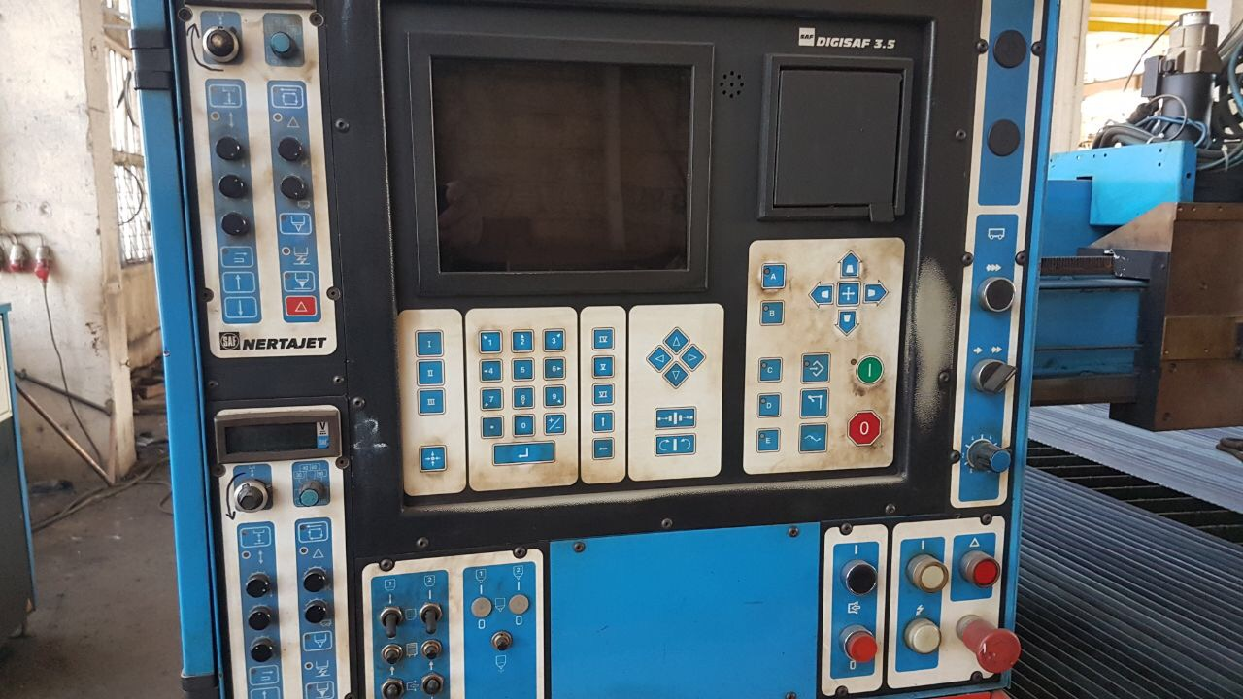
- Cutting thickness : 20

- Table height : 700
- Rail height : 550
- Middle rail side table : 544

- Fast speed rapid : 15 M/Min
- 2 range work speed : 0 – 10 M/Min

- 2 x Plasma NETRAJET HP 120
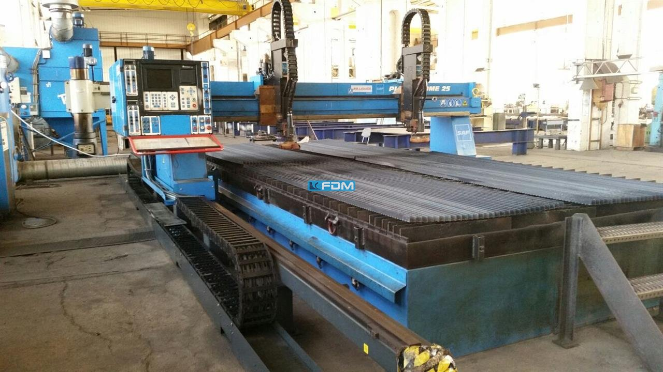
- CNC DIGISAF 3.5
- Double motorised

- Dimensions
- Length : 9.530
- Width : 6.020
- Height : 2.500
- Weight : 8.200

- Power source NETRAJET
- Torch shock protection

Please Note: The above information has been obtained to the best of our ability and belief from, and from the manufacturers where possible. It is given in good faith, but its accuracy can not be guaranteed. Accordingly, it will not form a representation or constitute contractual terms. We advise you to check any vital details!

